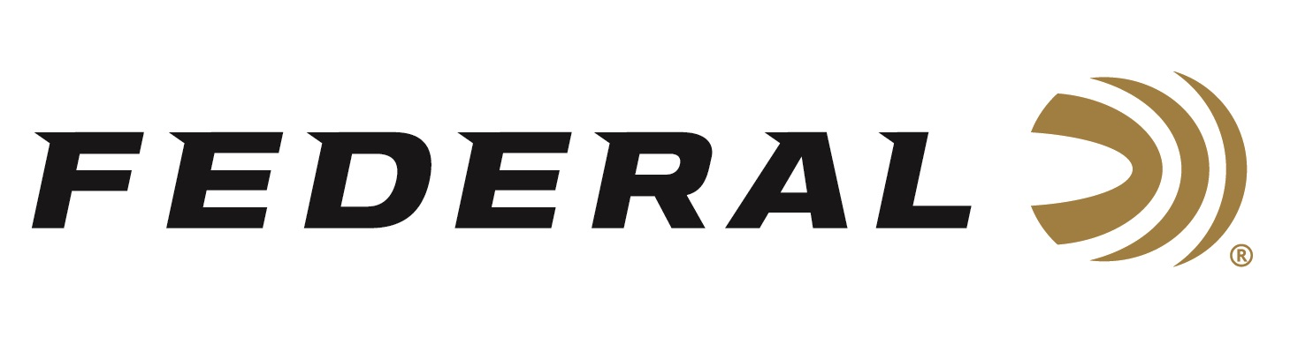

FOR IMMEDIATE RELEASE

**Federal Ammunition Sponsored Shooters Capture Titles at Gamaliel Cup**

**ANOKA, Minnesota –** **April 7, 2025 –** Federal Ammunition congratulates sponsored shooters Cameron Hicks and Abel Spire for top podium finishes at the 2025 Gamaliel Cup. The event took place at the Crossville Shooting Sports Park in Crossville, TN the weekend of April 3-6, 2025. More than 330 shooters participated in the competition.

Hicks won two events over the weekend, topped off by capturing the Main Event High Over All in a shoot-off. Hicks bested the field of 260 shooters with Federal’s new Master Class offering; a sporting clay load designed for the competition shooter. His second High Over All came in the Super Sport event.

“I shot the 1 1/8 oz., 1235 load and I love the blue hull, and it pounds targets,” said Hicks. “The shoot was one of the windiest events of the year so far, so having that extra 1/8 ounce of shot made a huge difference.”

Federal’s Abel Spire also won two events during the four-day competition. Spire earned the High Over All in the 5-Stand event and ran 50 straight to win the True Pair event. Spire also finished third in the Super Sport event.

Master Class is a new competition-level sporting clay load that features a customized Podium wad, which extracts peak performance from Federal’s straight-wall hull. Reliable primers, high-antimony lead shot, and select propellant combine to break the most challenging targets.

To support America’s shooting team, visit [www.usashooting.org](http://www.usashooting.org) to find out more.

Federal Ammunition products are available at dealers nationwide and online. For more information on all Federal products, visit [www.federalpremium.com](http://www.federalpremium.com).

**Press Release Contact:** JJ Reich

Senior Manager – Press Relations

E-mail: media@tkghunt.com

**About Federal Ammunition**

Federal, headquartered in Anoka, MN, is an ammunition brand of The Kinetic Group, owned by CSG, a globally diversified industrial group based in Prague (Czech Republic). From humble beginnings nestled among the lakes and woods of Minnesota, Federal Ammunition has evolved into one of the world's largest producers of sporting ammunition. In 1922, founding President Charles L. Horn paved the way for our success. Today, Federal carries on Horn's vision for quality products and services with the next generation of outdoorsmen and women. We maintain our position as experts in the science of ammunition production. Every day, Federal manufactures products to enhance our customers' shooting experience while partnering with the conservation organizations that protect and support our outdoor heritage. Federal offers thousands of options in our Federal Premium® and standard Federal® lines, which is what makes it the most complete ammunition company in the business and helps it provide customers with a choice no matter what the pursuit.